|  |
| --- |
|  |

# Introduction:

C is a popular, easy-to-learn, and adaptable general-purpose programming language. It is a machine-independent structured programming language that is widely used to write applications, operating systems like Windows, and numerous complex programs like the Python interpreter, Oracle database, and Git. C is said to be the programming language of the gods. One could say that the programming is based on C. You can easily understand the other programming languages that use the C concept if you know C. (w3schools, n.d.)

# Design:

The software is an Elections Management System (EMS) which allows users to finish an assortment of event-related duties. The primary menu has three options:

First we have a common interface for user or admin for when we run code:

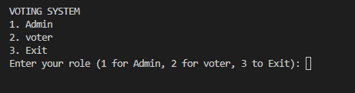

## Admin Login

After running the program if user can choose option 1 then we need to enter passcode to access the admin panel   
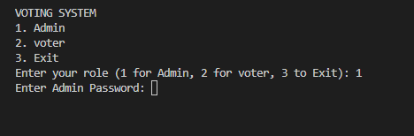

After entering the correct passcode the user can able to access the feature of admin dashboard of voting system.

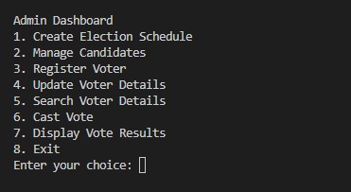

After getting access of admin side admin can do 7 tasks those are   
1. Create Election Schedule

2. Manage Candidates

3. Register Voter

4. Update Voter Details

5. Search Voter Details

6. Cast Vote

7. Display Vote Results

### Create Election Schedule: If the admin choose the Create Election Schedule then, Admin can enter details about an electoral area and its election date.

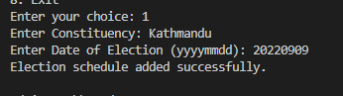

After, creating election date admin can return to the admin dashboard.

### Manage Candidates

After creating election admin can manage the candidates that is Add candidates to the candidate list, including their name, political party, and candidacy details. Also, admin can update and remove candidates from the list.

When admin choose manage candidates options there is 4 options that is

1. Add Candidate

After choosing 1 in the option that is for add candidate .Admin can add the candidates for the election: where admin need to enter details about the candidates. Those are name,party,Address.

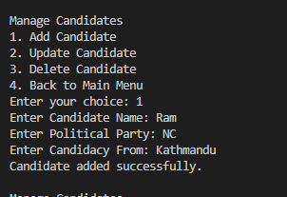

2. Update Candidate

If admin need to update candidates details admin should chose option 2 and enter name of the candidates:

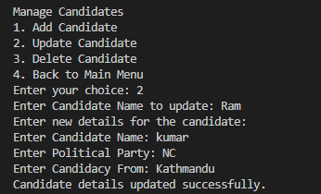

3. Delete Candidate

If admin wants to delete the candidates, admin shoul choose option 3 and enter the name to delete the candidates:

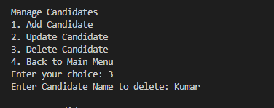

4. Back to Main Menu

If admin wants to get back to main dashboard admin should choose option 4.

### Register Voter

Administrators can register new voters by providing their serial number, name, date of birth, address, and password. By checking that the voter is at least 18 years old.

First admin will ask for age to ensure that voter was eligible for voting or not.

Then we need to enter serial number, Date of Birth, Address, and password of Voter.

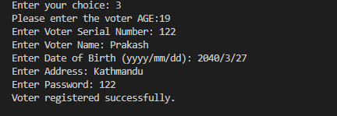

### Update Voter Details

Admin can update voter data by entering the serial number and updating the necessary information.

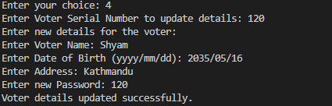

### Search voter Detail’s

Admin can search for and indicate details about a voter via the voter's serial number.

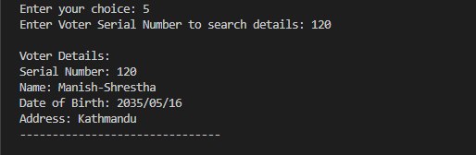

### Display vote results

Admin can publish the vote by entering number 7.

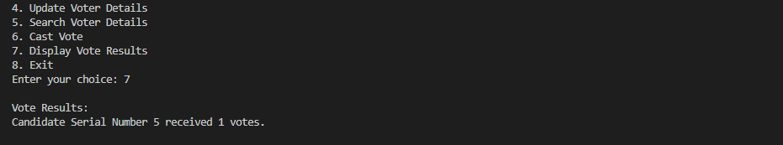

### Logout

The option 8 exit works as logout.

## Voter Dashboard

After running the program if user can choose option, then we need to enter passcode to access the voter panel:

To access the voter we need to login first where we need to enter serial number and password that was provided by the admin.

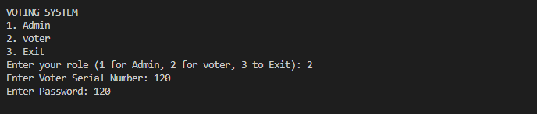

Voter can access the

1. voter can update the own details
2. Cast the vote
3. Display the results
4. Exit

**2.2.1. Update voter details**

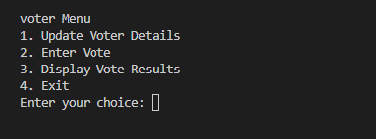

**2.2.2. Enter Vote**

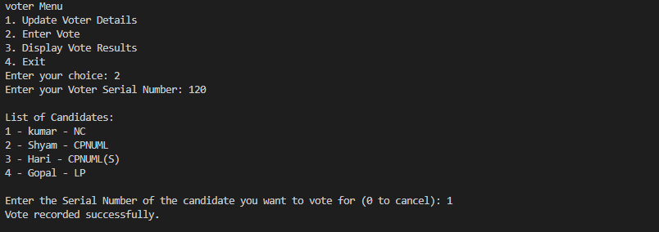

**2.2.3. Display Vote**

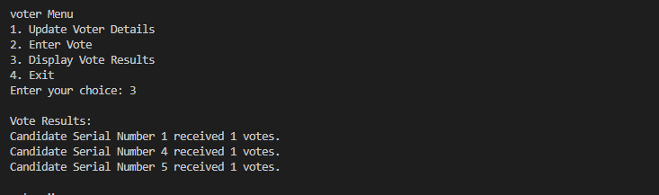

When the user selects an option, the application prompts them for further information.

When a user selects the "Administrator Login" option, they must input a username and password. After a successful login, the program displays a menu with the following options: The user can select an option by entering the corresponding number.

If you select the incorrect choice, the program will display an error message. If a user selects the voter registration option, the program prompts them to provide personal information such as their name, address, age, and voter ID. Details are saved to a file. When a person selects the "Vote" option, they are prompted to enter their account and password.

When a user picks a voting option, they are asked to provide their login and password.

Following successful registration, the application presents a list of candidates and allows the user to choose one and vote.

When a vote is cast, the computer updates the total number of votes for the chosen candidate.The application also has tools for executing election-related operations, such as developing an election plan, storing voter information to a file, reading voter information from a file, and so on.

Overall, this program aims to provide: A user-friendly interface for managing elections and ensuring fair and transparent outcomes.

# Pseudocode:

For better human comprehension, the informal programming style known as pseudocode can be found in C. Because it is written in straightforward English, the complex program is made simpler to comprehend. (geeksforgeeks, 2023)

It is impossible to compile or interpret pseudocode. It doesn't follow the syntax of the programming language; therefore, it is written in pseudocode to make it simple for both programmers and non-programmers to comprehend. (wikihow, 2023)

// Define Structures

struct ElectionSchedule {

char constituency[50];

char date[9];

};

struct Candidate {

int serialNumber;

char name[50];

char party[50];

char candidacyFrom[50];

};

struct Voter {

int sno;

int age;

char name[50];

char dob[11];

char address[50];

char password[20];

};

// Function Prototypes

void createElectionSchedule();

void manageCandidates();

void registerVoter();

void updateVoterDetails();

void searchVoterDetails();

void castVote();

void displayVoteResults();

void adminMenu();

void voterMenu();

int authenticateVoter(int sno, const char *password);

// File Names

const char scheduleFileName[] = "schedule.txt";

const char candidateFileName[] = "candidatelist.txt";

const char voterFileName[] = "voterlist.txt";

const char voteCountFileName[] = "votecount.txt";

const char adminPassword[] = "admin123";

// Main Function

int main() {

// Display Initial Menu

// Prompt for Role Choice (Admin, voter, or Exit)

// Call respective function based on choice

// Return 0;

}

// Admin Menu

void adminMenu() {

// Prompt for Admin Password

// Check if Password is correct

// If correct, enter Admin Dashboard

// Display Admin Options

// Based on choice, call respective functions

// Repeat until Exit option is chosen

}

// voter Menu

void voterMenu() {

// Prompt for Voter Serial Number and Password

// Authenticate Voter

// If authentication successful, enter voter Menu

// Display voter Options

// Based on choice, call respective functions

// Repeat until Exit option is chosen

}

// Function to Authenticate Voter

int authenticateVoter(int sno, const char *password) {

// Open Voter File

// Read each voter's Serial Number and Password

// Check if provided sno and password match any record

// If match found, return 1 (Authentication successful)

// If no match found, return 0 (Authentication failed)

// Close Voter File

}

// Function to Create Election Schedule

void createElectionSchedule() {

// Open Schedule File

// Prompt for Constituency and Date

// Write schedule details to the file

// Display success message

// Close Schedule File

}

// Function to Manage Candidates

void manageCandidates() {

// Display Candidate Management Menu

// Based on choice, add, update, delete candidates, or go back to Main Menu

}

// Function to Register Voter

void registerVoter() {

// Open Voter File

// Prompt for Voter Details

// Check if Age is valid

// Write voter details to the file

// Display success message

// Close Voter File

}

// Function to Update Voter Details

void updateVoterDetails() {

// Open Voter File and Temporary File

// Prompt for Voter Serial Number to update details

// Read each voter's details

// If match found, update details, else write to temp file

// Display success message or not found message

// Replace Voter File with the Temporary File

// Close both files

}

// Function to Search Voter Details

void searchVoterDetails() {

// Open Voter File

// Prompt for Voter Serial Number to search details

// Read each voter's details

// If match found, display details

// Display not found message if no match found

// Close Voter File

}

// Function to Cast Vote

void castVote() {

// Open Candidate File and Vote Count File

// Prompt for Voter Serial Number

// Authenticate Voter

// If authenticated, display candidates and prompt for vote

// Record the vote in the vote count file

// Display success message

// Close both files

}

// Function to Display Vote Results

void displayVoteResults() {

// Open Vote Count File

// Count votes for each candidate

// Display total votes for each candidate

// Close Vote Count File

}

# Flowcharts:

Flowcharts are useful visual aids that allow programmers to visually represent algorithms or programs. Programmers can more easily comprehend and analyze intricate code structures thanks to flowcharts, which show the processes, information flow, and connections that take place within an algorithm or program. They are especially helpful when programmers need to visualize a program's logic and decision-making processes during the planning and debugging stages. (zenflowchart, 2022)

Flowcharts can help non-technical people understand how a program works in addition to their technical applications. Flowcharts make it simpler for non-programmers to comprehend the inner workings of a program by employing symbols and natural language. Various symbols, such as start and end points, decision points, process steps, and connectors, may be included in a basic flowchart. Combining these symbols allows for the representation of intricate decision trees, loops, and other program structures. (programiz, 2021)

Overall, flowcharts bridge the gap between technical and non-technical programming aspects in software development. They give a visual representation of the logic and structure of a program, making it simpler to find and fix mistakes and to explain programming concepts to a wider audience.

## Candidate register:

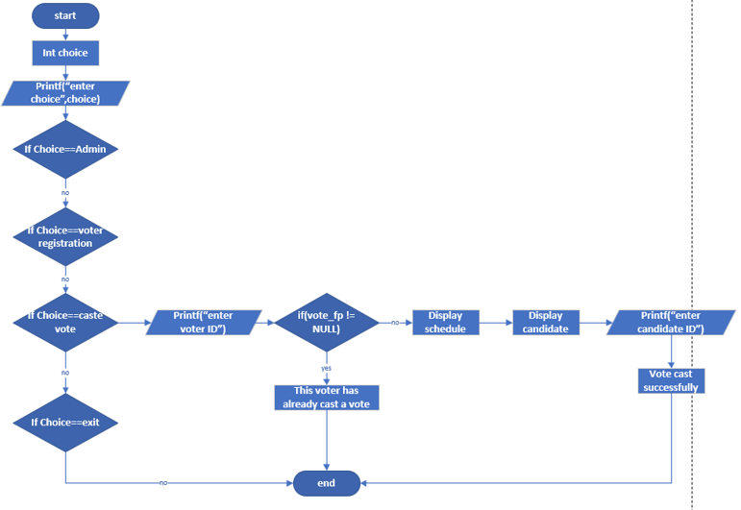

## Voter register:

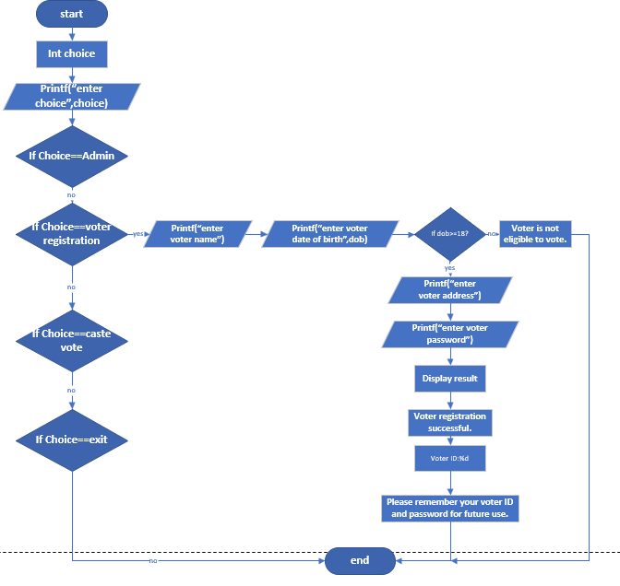

## Main function:

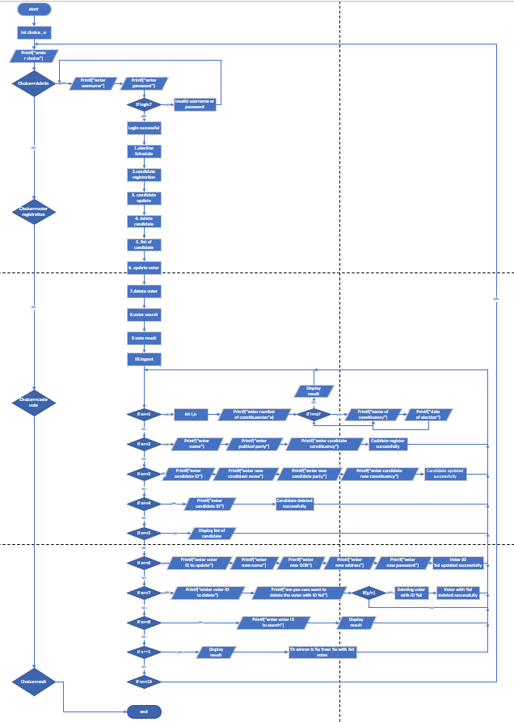

## Display panel:

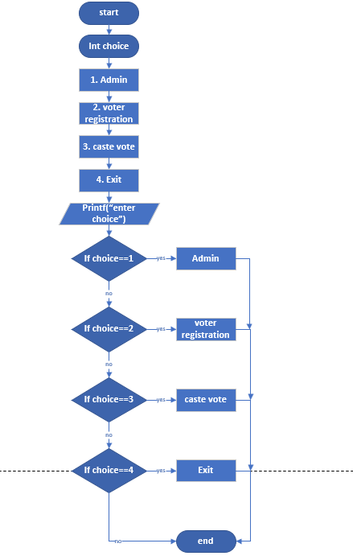

Conclusion:

The system must be designed to facilitate the secure and efficient conduct of an election, incorporating essential features such as voter and candidate registration, online voting, and result generation. The system must also ensure that all data stored in text files is secure and protected from any potential breaches. In addition, the system should provide a reliable and trustworthy platform for conducting the election, with measures in place to prevent unauthorized access or tampering with the data. Overall, the system should prioritize the integrity and confidentiality of the election process to ensure a fair and accurate outcome.

# Bibliography

geeksforgeeks. (2023, march 15). *What is PseudoCode: A Complete Tutorial*. Retrieved from geeksforgeeks: https://www.geeksforgeeks.org/what-is-pseudocode-a-complete-tutorial/

programiz. (2021, april 5). *Flowchart In Programming*. Retrieved from programiz: https://www.programiz.com/article/flowchart-programming

w3schools. (n.d.). *w3schools*. Retrieved 04 15, 2023, from w3schools.com: https://www.w3schools.com/

wikihow. (2023, february 23). *Learn to Write Pseudocode: What It Is and Why You Need It*. Retrieved from wikihow: https://www.wikihow.com/Write-Pseudocode

zenflowchart. (2022, march 10). *Flowchart In C Programming: Guide & Example*. Retrieved from zenflowchart: https://www.zenflowchart.com/guides/flowchart-in-c-programming

# 